

PROJECT REPORT

Student Name – Vedant Vyas
Student Regn. No. – 23BAI11349
Winter Semester – 2025-2026
Year – 3rd
Semester – 8th
Slot – D11+D12

Faculty Name – Amrita Parashar Ma’am
School of Computer Science Engineering and Artificial Intelligence (SCAI)
VIT Bhopal University

INDEX

S. No. | Topic | Page No.
1 | Executive Summary | 3
2 | Problem Statement & Motivation | 4
3 | System Architecture | 5
4 | Technical Implementation: The ML Pipeline | 6
5 | Automated Damage Assessment Metrics | 7
6 | Engineering Challenges & Solutions | 8
7 | Website | 9
8 | Learning Outcomes & Future Work | 10

DeepSign Vision — AI-Powered Road Sign Damage Detection

1. Executive Summary
DeepSign Vision is a full-stack infrastructure monitoring solution developed to automate the detection and condition assessment of road signage using computer vision techniques. The system is designed to address a common real-world problem where damaged, faded, or occluded road signs often go unnoticed due to reliance on manual inspections. By integrating modern AI models with practical image processing techniques, the project aims to provide a faster, more reliable, and scalable alternative.
The core idea behind this project is to move from a reactive inspection system to a proactive, data-driven approach. Instead of waiting for complaints or periodic manual surveys, DeepSign Vision can analyze images of road environments and instantly identify traffic signs along with their condition. This significantly reduces human effort while also improving consistency in evaluation.
The system uses a multi-stage pipeline where a YOLOv8 model first detects the presence of traffic signs in an image. These detected regions are then passed to a ResNet50-based classifier for fine-grained recognition of the sign type. To improve accuracy and reduce incorrect predictions, additional heuristic logic such as shape detection, color filtering, and directional analysis has been incorporated. This combination of deep learning and traditional computer vision helps achieve more reliable results.
A key feature of this project is the generation of a “Severity Score,” which quantifies the level of damage on a scale from 0 to 100. This score is calculated using multiple factors such as blur, color fading, structural integrity, and occlusion. Based on this score, each sign is categorized into low, medium, or high severity, making it easier to prioritize maintenance actions.
Overall, DeepSign Vision demonstrates how AI can be practically applied to infrastructure monitoring. Through this project, I explored not only model integration but also real-world challenges like handling noisy detections, scaling outputs for frontend visualization, and ensuring consistent inference. The final system provides a working prototype that highlights the potential of automated road safety monitoring solutions.
2. Problem Statement & Motivation
Road signage is a critical component of public safety, yet its maintenance is often reactive rather than proactive. In many municipalities, damaged or faded signs are only identified through manual "drive-by" inspections or citizen reports, which are not only slow but also inconsistent. This results in several challenges:
- Safety Risks: Faded or occluded signs (e.g., STOP signs hidden by foliage) can confuse drivers and increase the likelihood of accidents.
- Economic Inefficiency: Manual inspections require significant time, manpower, and resources, making them costly and difficult to scale.
- Inconsistent Data: Since inspections depend on human judgment, there is no standardized way to measure or compare the level of damage, leading to subjective maintenance decisions.
- Delayed Response: Issues are often addressed only after complaints or incidents occur, rather than being detected early.
- Lack of Real-Time Monitoring: Traditional systems do not provide continuous or automated tracking of road conditions.
To address these issues, I developed DeepSign Vision as an automated and standardized solution. The system is designed to analyze road images efficiently, detect signage, and assign objective severity scores. By combining computer vision with practical heuristics, it helps in identifying high-priority maintenance areas more accurately and supports a more proactive, data-driven approach to infrastructure monitoring.

3. System Architecture

The application is built on a heterogeneous tech stack designed to balance performance, scalability, and modularity. Each component is responsible for a specific part of the pipeline, allowing the system to remain flexible and efficient:
- Frontend (React 19 & Vite): The frontend is designed as a responsive dashboard that provides an intuitive user experience. It uses Framer Motion to add smooth micro-animations and follows a modern glassmorphism design for better visual appeal. The interface handles image uploads, displays results, and renders dynamic bounding boxes on an HTML5 Canvas. Special attention was given to ensuring that the bounding boxes scale correctly across different screen sizes, making the visualization accurate and user-friendly.
- Backend (Node.js/Express): The backend acts as a bridge between the frontend and the machine learning layer. It is built using Express.js to handle API requests efficiently and supports file uploads using Multer. One important design decision was to offload heavy ML processing to a separate Python process. This ensures that the Node.js server remains non-blocking and can handle multiple requests concurrently without performance issues.
- ML Engine (Python/PyTorch): The machine learning layer is the core of the system. It performs object detection, classification, and damage analysis using a combination of deep learning models and traditional image processing techniques. PyTorch is used for model inference, while OpenCV-based heuristics are applied to refine predictions and analyze sign conditions. This hybrid approach improves reliability and allows the system to handle real-world variations more effectively.

4. Technical Implementation: The ML Pipeline
The system utilizes a multi-stage inference strategy to improve accuracy and reduce incorrect predictions. Instead of relying on a single model, the pipeline is divided into multiple stages, where each stage refines the output of the previous one.
A. Localization (YOLOv8)
The first stage focuses on detecting where traffic signs are present in the image. For this, a YOLOv8 (You Only Look Once) model is used because of its speed and efficiency in real-time object detection. It identifies bounding boxes around potential traffic signs, and these regions of interest (ROIs) are then passed to the next stage.
B. Classification & Refinement (ResNet50)
While YOLO is effective for detection, it may not always provide highly accurate classification for closely related sign types. To address this, each cropped ROI is passed to a ResNet50-based convolutional neural network, which is fine-tuned to recognize multiple traffic sign categories. This two-step approach improves overall classification accuracy.
C. Semantic Logic & Heuristics
To further reduce errors, an additional rule-based filtering layer is applied:
- Shape Analysis: Uses Canny edge detection and contour approximation to identify the geometric shape of the sign.
- Color Masking: Applies HSV-based color filtering to match expected color patterns (e.g., STOP signs being red).
- Directional Heuristics: Resolves ambiguity between left and right arrows by analyzing pixel distribution.
Overall, this multi-stage pipeline combines deep learning with traditional computer vision techniques, resulting in a more robust system for real-world scenarios.

5. Automated Damage Assessment Metrics
The "Severity Score" (0–100) is used to quantify the overall condition of a detected road sign. Instead of relying on a single factor, the system calculates this score using a weighted combination of multiple visual indicators. This approach helps in capturing different types of damage more accurately and provides a more balanced assessment.
- Blur Variance (25%): This is calculated using the Laplacian Variance method, which measures image sharpness. A low variance indicates blur, which may result from physical damage or motion during capture.
- Color Saturation (25%): This metric analyzes the average saturation value in the HSV color space. A drop in saturation indicates fading, which reduces the visibility of the sign.
- Structural Integrity (30%): This is evaluated using Canny Edge Density, which measures how well the edges of the sign are preserved. Damaged signs with cracks, bends, or missing parts tend to have irregular or broken edge patterns, leading to deviations from the expected structure.
- Occlusion Ratio (20%): This measures how much of the sign is covered by external elements such as foliage, dirt, stickers, or graffiti. It calculates the ratio of visible sign-colored pixels to the total area, helping detect partial obstruction.
The final severity score is computed by combining these factors based on their respective weights, ensuring that no single metric dominates the evaluation.
Severity Levels:
- LOW (0–30): The sign is in good condition and clearly visible. No immediate action is required.
- MEDIUM (31–70): The sign shows moderate degradation (e.g., fading or partial occlusion) and should be considered for maintenance.
- HIGH (71–100): The sign is severely damaged, poorly visible, or obstructed, and requires immediate attention or replacement.
This scoring system provides a standardized and objective way to assess road sign conditions, making it easier to prioritize maintenance efforts.

6. Engineering Challenges & Solutions
Cross-Platform Path Compatibility
During development on Windows, I encountered an issue where pre-trained models (typically saved in Linux environments) caused a ModuleNotFoundError related to pathlib.PosixPath. This happened because certain libraries expected Linux-style paths, which are not directly compatible with Windows.
- Solution: To resolve this, I implemented a dynamic monkey-patch in the inference script that maps pathlib.PosixPath to pathlib.WindowsPath when the code is executed on Windows. This ensured that the model loading process worked correctly across different operating systems.
Responsive Coordinate Scaling
Another major challenge was accurately mapping bounding box coordinates from high-resolution images (e.g., 4K) processed in Python to a responsive React-based frontend. Since the displayed image size on the browser varies depending on screen resolution and layout, directly using raw coordinates resulted in misaligned bounding boxes.
- Solution: I developed a scaling utility that calculates the ratio between the original image dimensions and the dynamically rendered canvas size. This ratio is then applied to all bounding box coordinates, ensuring that overlays remain properly aligned and visually accurate across different devices and screen sizes.
Multi-Sign Conflict Resolution
While using YOLO for detection, I observed that the model occasionally produced multiple overlapping bounding boxes for a single physical sign, especially in complex scenes or when confidence scores were similar. This could lead to duplicate detections and inconsistent results.
- Solution: To handle this, I implemented a custom conflict resolution mechanism inspired by Intersection Over Union (IoU) logic. The system compares the distance between detection centers and identifies overlapping regions. If two detections are too close, it retains only the one with the higher confidence score, ensuring cleaner and more reliable output.

7. Webiste
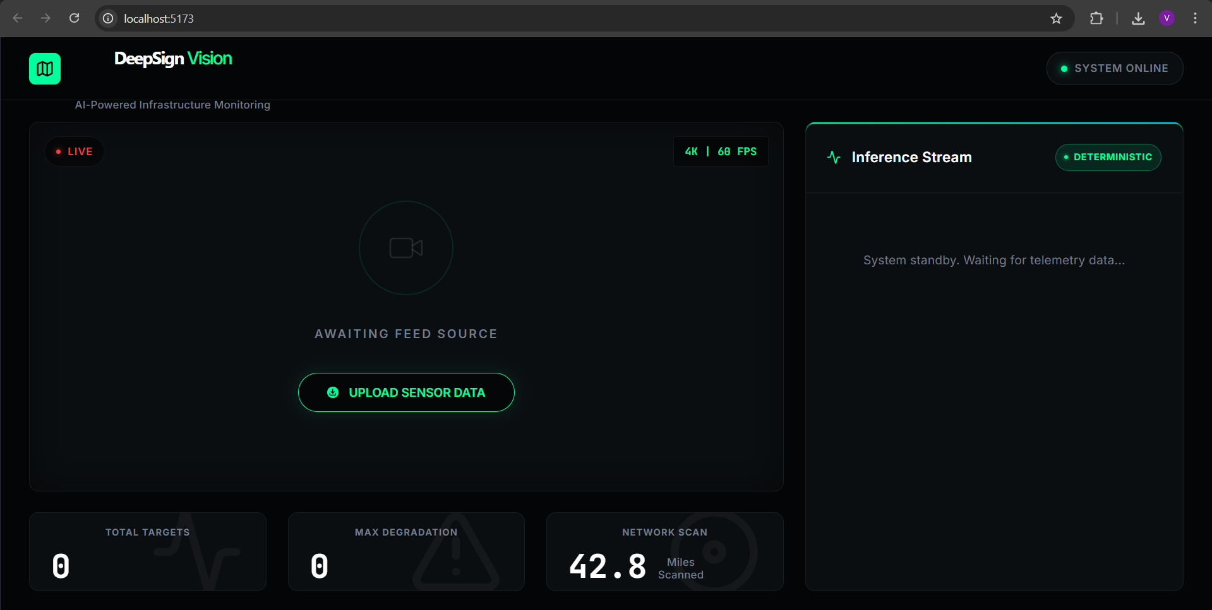
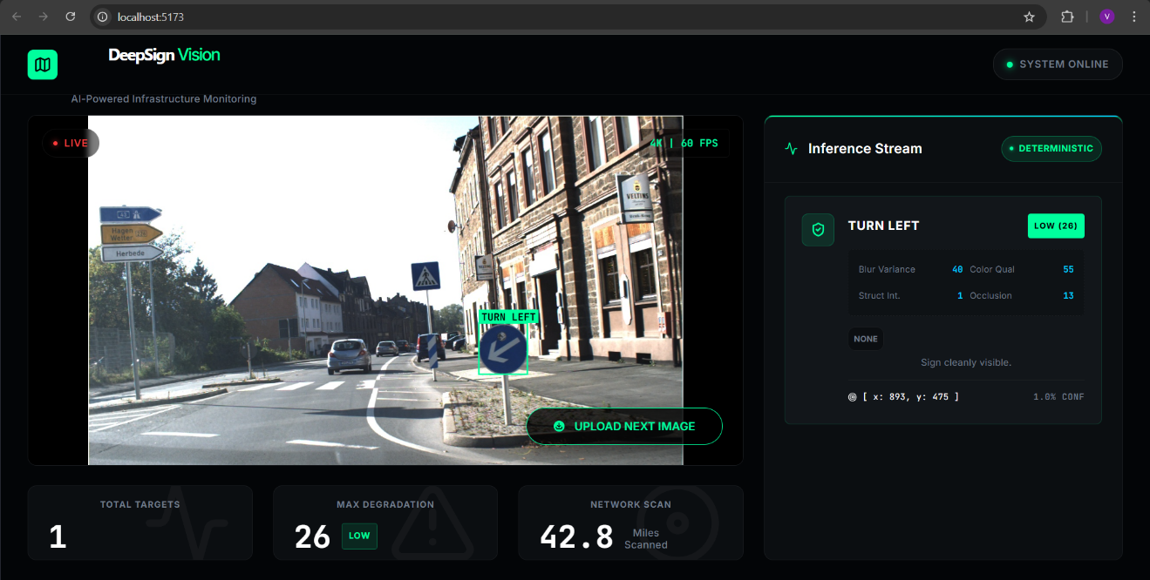
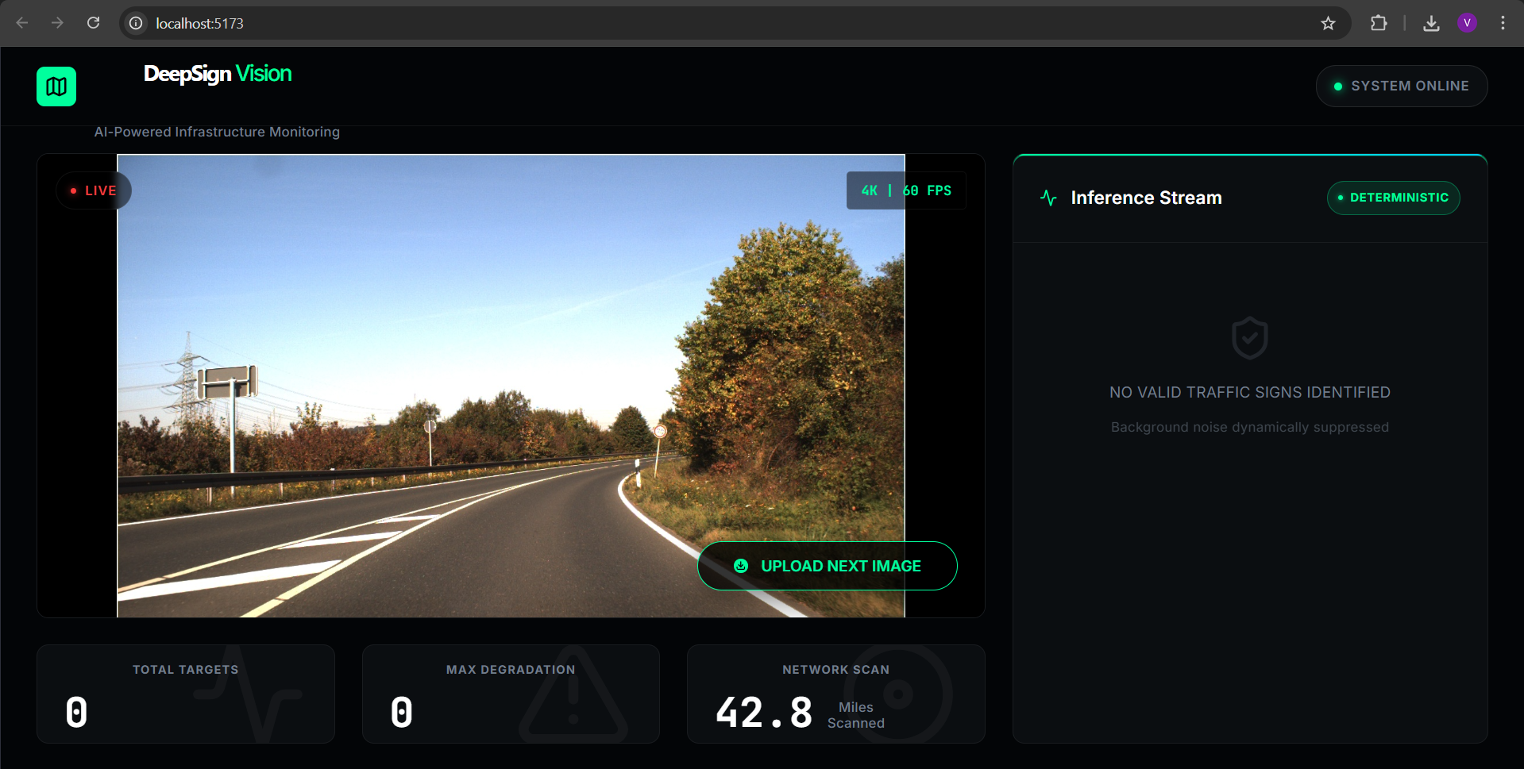
8. Learning Outcomes & Future Work
This project significantly deepened my understanding of Deterministic Inference, where the goal is to ensure that the model produces consistent and stable outputs even when there are variations in input conditions such as lighting, noise, or image quality. While working on this, I realized how small inconsistencies in preprocessing or randomness can affect results, and how important it is to control them for reliable performance.
It also helped me understand the value of Hybrid AI, where traditional Computer Vision techniques (using OpenCV) are combined with deep learning models (PyTorch). Instead of relying entirely on one approach, integrating both allowed me to improve accuracy and handle edge cases more effectively. This combination made the system more practical and robust for real-world scenarios.
Next Steps:
- GPS Integration: Automatically tag images with location data (EXIF metadata) and visualize detected damaged signs on a map interface such as Google Maps. This would make the system more useful for large-scale monitoring and tracking.
- Deployment: Containerize the application using Docker to manage dependencies like PyTorch and OpenCV more efficiently. This would also make it easier to deploy the system across different environments without compatibility issues.
- Real-Time Processing: Extend the system to support live video feeds for continuous monitoring instead of static image uploads.

Developed as a Capstone Project for AI Infrastructure Monitoring.

